TRIANGLE THEATER REVIEW
BY PAMELA VESPER
The Old Man and the Sea at Carolina Performing Arts:
What a Show! Weird, Beautiful, Wonderful, Bizarre!
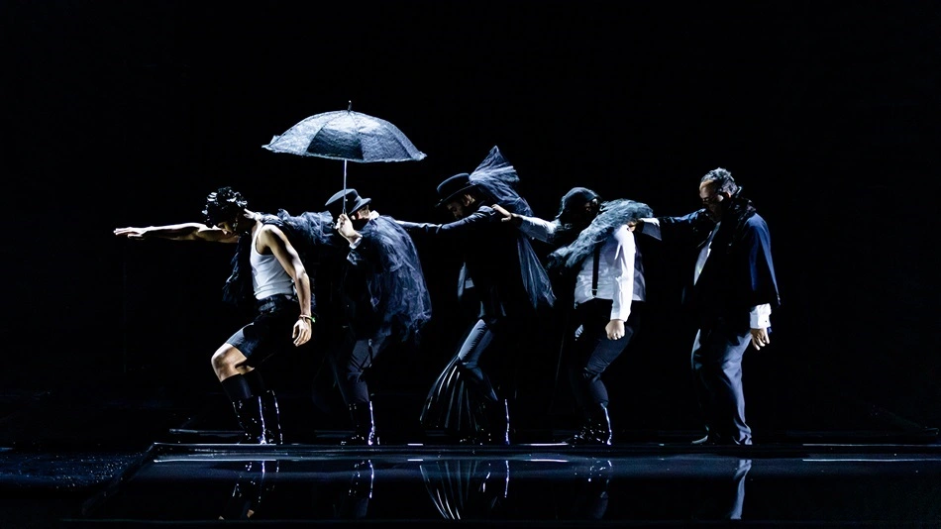
Carolina Performing Arts presented The Old Man and the Sea, a new opera from Paola Prestini, Royce Vavrek, and
Karmina Šilec, at 8 p.m. Saturday, Feb. 10th, in Memorial Hall at the University of North Carolina at Chapel Hill
Opera. I love opera. I love the pageantry, the storytelling, and the amazing vocals. Most people who say they don't like opera claim it is not sung in English or they think that opera is dusty old stories filled with women with horns and shields. Well, it is time to revisit everything you know about the opera, because it is a brave new world, and this new opera, Carolina Performing Arts' Saturday, Feb. 10th, presentation of The Old Man and the Sea, is a game-changer.
What appears to be a big fish story is really an avant-guarde examination of Ernest Hemingway's life, aging, mortality, and humanity's complicated relationship with nature. This is no linear telling of a fish tale, however. The Old Man and the Sea opera, created by Paola Prestini, Royce Vavrek, and Karmina Šilec, is an avant-guarde swirl, a fever-dream of sights and sounds, and a visual feast meant to lure the audience into its net.
The Hemingway tale centers on an aging Cuban fisherman, Santiago (Armando Contreras), who is desperate to prove his worth by catching a giant marlin that no one seems to be able to catch. His young apprentice, Manolin (Rudy Giron), brings Santiago bait fish and hopes to learn from his experienced mentor; but Santiago's luck has run out, and he is focused on heading to sea on his own to snag the great fish.
The story takes on new depth when one recognizes the parallels the story has to Hemingway's own life. Hemingway, who lived for many years on a farm in Cuba, suffered many hardships, including debilitating depression, alcoholism, cirrhosis of the liver, mental health issues, and diabetes. Yet, like his character, Santiago, Hemingway was obsessed with being strong, proving his masculine presence and conquering nature, and many of his stories such as The Sun Also Rises, The Snows of Kilimanjaro, and For Whom the Bell Tolls have themes about man against nature. Although this is the story of Santiago, the fisherman, it is also the story of Hemingway, and by extension, our own journey through the trials and tribulations of life.
The set itself is a modern masterpiece. Inky, ethereal images act as a backdrop for modern motion. As this is a tale set on the ocean and on boats, the principals and the back-up choir don heavy black rain coats and shiny black boots. They slosh through shallow, rectilinear, inky pools of water. Images of the sea are projected on the ceiling and the proscenium. There are low murmurs and swirls of sound and wind. Fishermen and women come and go, constantly tired, working, wet. It rains. It even snows.
The audience can feel the brutality of life and of nature. In addition, the sea personified (Measha Brueggergosman-Lee) is a force to be reckoned with, and the Cuban Patron Saint of Charity (Yvette Keong) watches over them all. Kudos to set designer Dorian Šilec, lighting designer Andrej Hajdinjak, and sound designer Garth MacAleavey. They have created a marvel in the style of Cirque du Soleil's "O". Thanks must also must go to cellist Jeffrey Zeigler, percussionist Shayna Dunkelman, the choir and the symphony (conducted by Mila Henry), who imbued the theater with sadness and feeling that only live music can bring.
The Old Man and the Sea is Santiago's shot at redemption. Killing a fish may not seem elevating, ultimately; but we come to admire Santiago's grit, his acceptance that plans do not always work out as planned, and his final acceptance of where he is in life and his ultimate death. This opera is edgy and surreal, a fish stew of amazing voices, music, and oddities.
Just like life, The Old Man and the Sea examines themes of man against nature, aging, isolation, human suffering, and perseverance and, ultimately, human redemption. Just don't walk in expecting a linear story. Let the visuals take you on a voyage of sensory exploration, feel the ebbs and flows as they come, and let the beauty of the tale sweep you away. Just don't expect a happy ending.

